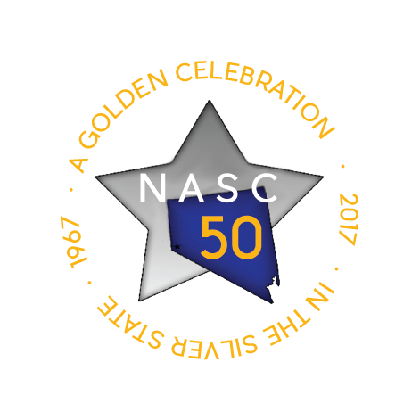
2016 MidLevel RT0 Information
(RoundTable Only)

Sophomores cannot be JCs at the MidLevel Conference, but they CAN apply to present a RoundTable Only (RTO)! Juniors and Seniors who cannot attend JC training can apply to present a RTO.

Roundtable topics must be suitable for middle level students.

RTO presenters apply individually and present BOTH sessions. (approx. 1:00– 2:45 PM)

RTO Selection will be based on Roundtable topic, outline, and handout.
Each school may submit 1 or 2 RoundTable Only applications.

General Roundtable Information
- Presenters will present at a table in the cafeteria with a group of 6-10 students per rotation.
- Activities will be at a table in a noisy room so plan accordingly
- There will be three 8-10-minute rotations.
- No icebreakers needed!
- Presenters should bring 60 copies of their handout(s).
- There will be no A/V equipment provided. (additional A/V information below)

Suggested Roundtable topics:
Remember to tailor your topic to MIDDLE SCHOOL STUDENTS!

- Committees (how to use/work in)
- Communication (be specific!)
- Community Service
- Dance decorations
- Dance planning
- Decision making
- Diversity/acceptance
- Events
- Fundraising
- Leadership skills
- Meeting skills
- Poster making
- Problem solving
- Project evaluation
- Publicity
- School Service
- Self-concept
- Staff appreciation
- Student recognition
- Time management

Powerpoint and/or Video for Roundtable presentations:
- Students are welcome to bring a laptop/tablet if they have a video/power point for their presentation.
- Movie/video clips must be from movies rated “G” or pre-approved by Mrs. Ginger.
- Movie/video clips should be saved with subtitles because it will be too loud to hear!
- There will be no access to power, so be sure the battery is charged!
- JCs are responsible for the laptop/tablet during the conference.

2016 MidLevel RTO Application
WHAT TO SUBMIT

Note to Advisor – REVIEW the handouts before submitting ☺
- Make sure all the required information is included and is age appropriate.
- 1 or 2 applications per school: students apply individually –not pairs like JCs

By September 29, 2016, RTO applicants will complete the google form:
http://tinyurl.com/MLRTapp

By September 29, 2015, the following RTO documents must be submitted via www.dropitto.me/NASCginger upload code = Silverstar
IMPORTANT: If you do not follow the naming rules, your documents will be deleted without review.

Document #1: Outline Save as .doc, .docx or PDF

Name of document #1: When you save your Roundtable outline, save as:
RTO your school, your last name (i.e. RTO Bonanza HS, Smith.docx)

Info in document #1
(In this order & in one continuous document)
- List the Roundtable title, presenter names & school at the top of the page.
- Outline of the 8-10 minute Presentation
  - DESCRIPTION of your workshop (20 words or less)
  - detail the information you will present
  - Do NOT send a script of your exact words.
  - Include your Prezi link (if applicable)
  - If you are using movie/video clips, include a description of each clip as well as an explanation of how it relates to your topic.

Document #2: Handout Save as .doc, .docx or PDF

Name of document #2: When you save your Roundtable handout document, save as:
RTO your school, your last name + “handout” i.e. RTO Bonanza HS, Smith HANDOUT.docx)

A Handout is required!
- The handout should be a good summary of the major points/topics from your presentation.
- Check it for spelling and grammar!
- One page is usually enough, but it can be more.
- Space for student to take notes is appropriate.
- Make it fun! ☺ (cool font, pictures or graphics)
- Be sure your name & school is on your handout (no contact info needed)

OPTIONAL Document #3: Powerpoint slides (if applicable)
Name your ppt: RTO your school, your last name + PPT
i.e. RTO Bonanza HS, Smith PPT.ppt

