9/11 Journal
Journal: For each image below, please explain what you think each picture is conveying and what emotions each image evokes in you. Explain. You can also describe initial reactions and any other connections you’ve made with the images. Please number your responses in accordance to each picture.

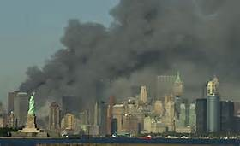
Image #1

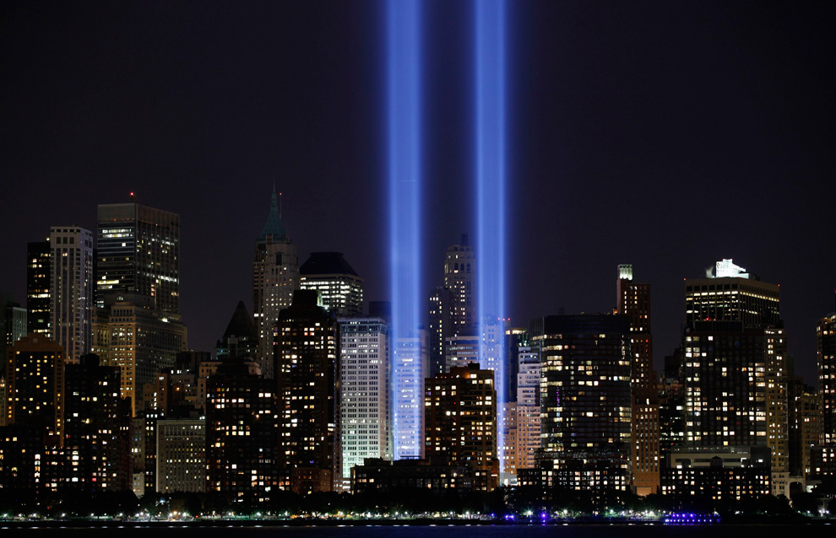
Image #2

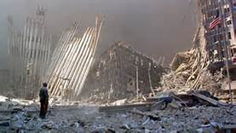
Image #3

